A History of Green Brands: 1980’s – Green Shoots Appear
Written by Landor Associates’ Chief Strategy Officer, Russ Meyers looks at the growing consumer awareness, their influence on brands and the emergence of green products.
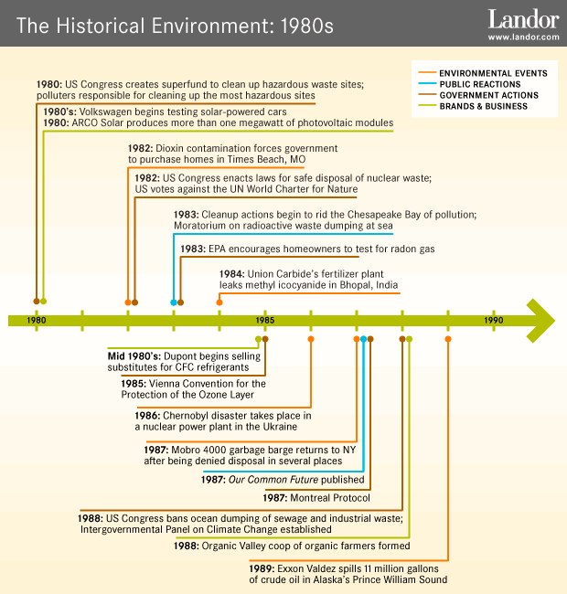
The 1980s—it was the era of big hair, big shoulder pads, and big weddings (Luke and Laura, Charles and Diana); the rise of the personal computer and the fall of the Berlin Wall. A recession in the United States in the early ’80s soon led to deregulation and business growth in many sectors, making icons of the financial “masters of the universe.” Despite this focus on wealth and consumption, a few green shoots were sprouting to indicate a small but growing awareness of environmental issues, or what we refer to today as “green.”
‘Ecopreneurs’
Many of the hippies of the 1960s who had dropped out in the 1970s were coming of age as entrepreneurs and business owners in the early ’80s. Some of today’s most recognized green brands trace their history and development back to this period—Whole Foods, Burt’s Bees, Seventh Generation, Tom’s of Maine, The Body Shop. These iconic green brands were all start-ups or burgeoning businesses in the early ’80s, emerging from the back-to-nature movement of the ’70s. Tom’s of Maine and Burt’s Bees began in rural communities selling natural products to like-minded customers. Whole Foods traces its history back to the merger of two natural food groceries. Despite offering different products, both Burt’s Bees and Whole Foods had visionary founders who created their brands because it was the right thing to do, not because of consumer or market demand. Although all of these companies started out as niche brands, it didn’t take long for any of them to find a market for their earth friendly products.
Emerging Consumer Interest
Individuals who may have considered themselves part of the counterculture 15 years ago were now busy making up the mainstream, working in corporations, and sending children off to school. But many of them hadn’t lost their interest in products that were better for them, easier on the earth, and made from more natural sources. This consumer group, particularly in the latter half of the 1980s, became large enough to be noticed and influence markets and manufacturing.
The Green Consumer Guide by John Elkington and Julia Hailes was the first to identify this emerging consumer. Published in 1988 and selling over 1 million copies, it was the first book of its kind to focus on green consumer choices. The guide detailed the chemical makeup of products in a number of different categories such as food, cleaning, and gardening, and it included resource lists for shopping, references for other publications, and even recipes for homemade green cleaning products. The popularity of The Green Consumer Guide demonstrated a growing green consumer market. And mainstream consumer-product companies raced to catch up with the demand for green and sustainable products.
Mainstream Brands Experiment
The 1980s ended with an explosion of new green products as companies both large and small tried to take advantage of consumer interest. Between 1989 and 1990, as the number of new green products more than doubled, they represented over 10 percent of all new household products. Popular well-loved brands quickly became targets for organized consumers who suddenly found their favorite brands wanting when it came to sustainability. For instance, in the late 1980s McDonald’s came under fire from many consumers, including a group called Kids Against Pollution, who persuaded friends and families to boycott McDonald’s and refuse food packaged in the ubiquitous polystyrene clamshells. Although this type of packaging was a very small part of the McDonald’s overall waste stream, it was soon banned in several communities after the company was subjected to mounting pressure relating to nonrecyclable waste. In 1990, McDonald’s finally announced that it was moving to paper-based packaging.
Based on the seeds of change planted in the 1970s, the 1980s was a decade of emerging growth—from little concern for the environment to one of the world’s biggest brands changing its packaging based on consumer demand. And those visionary entrepreneurs who had created green brands because they felt it was the right thing to do suddenly found themselves relevant to a consumer mindset interested in healthier, more sustainable products. The 1990s would be the decade in which mainstream brands began to experiment, as the evolving green consumer market grew in fits and starts.

